Lawnswood School Summer Maths Challenge

Complete these worksheets and hand them in to your maths teacher when you join us in September.

1. Write the sum of the column and row numbers in each space.

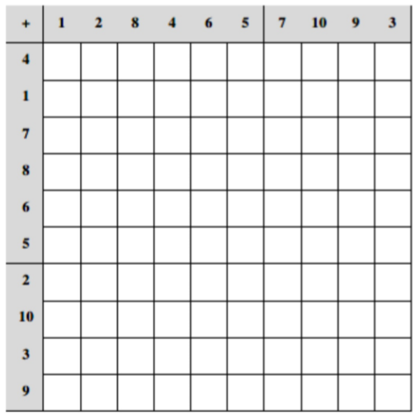

2. Write the product of the column and row numbers in each space.

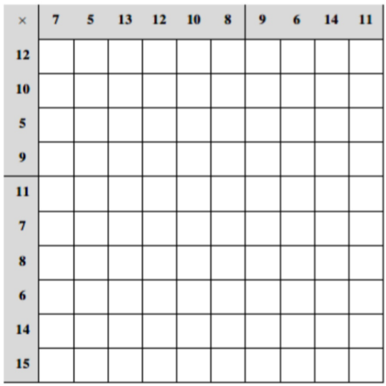

3. Add up each row, column and diagonal in the grids and place the sums in the boxes on the sides and bottoms.

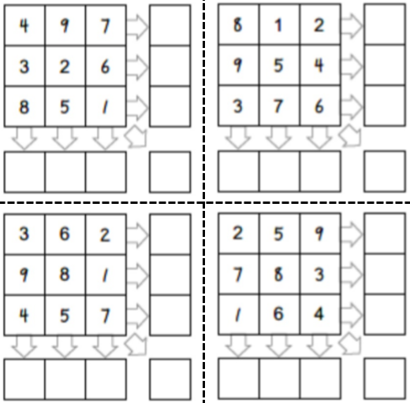

4. Each row, column and diagonal add up to the values shown. Can you logically fill in the rest of the grid of numbers?

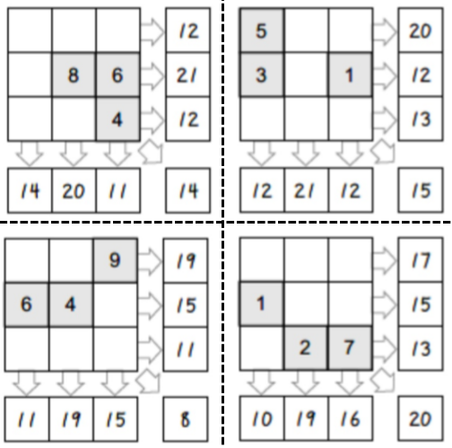

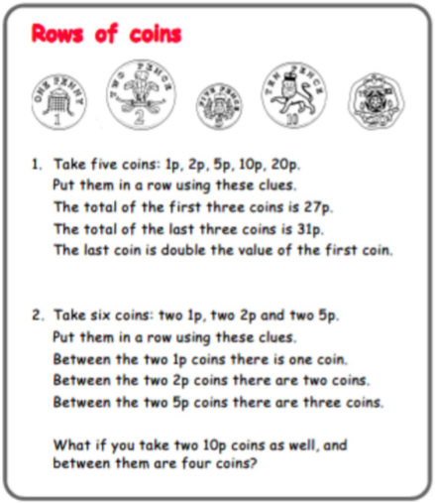

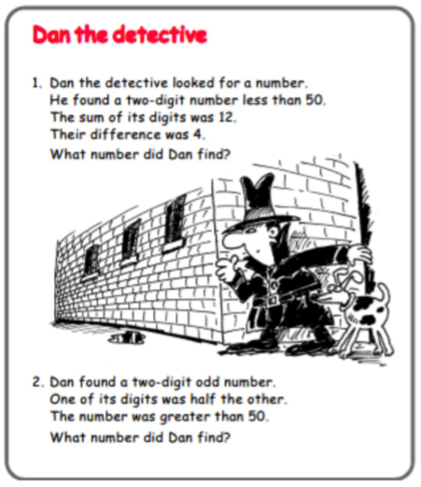

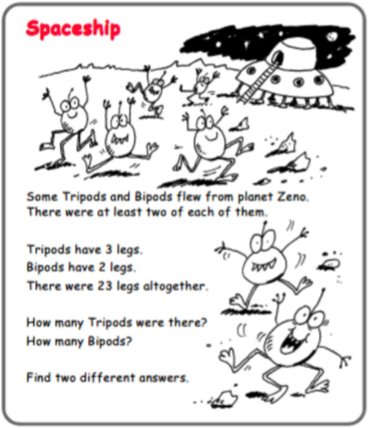
Each shape is located once in the grids on the left. None of the shapes overlap. Outline the shapes as you find them.

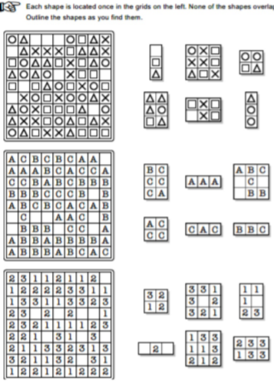
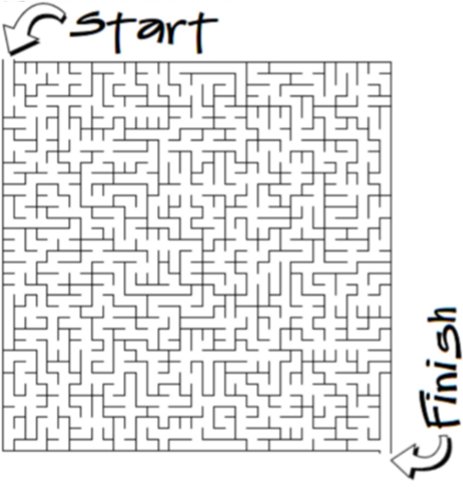
Some extra challenges to occupy you over the summer…

1a. What was the temperature on the hottest day during the summer?
1b. What was the temperature on the coldest day during the summer?
1c. Calculate the difference between these two temperatures.

2. Mr Smith likes small oranges. He likes to eat some every day. Over the summer, he will eat 3 oranges a day on the days with a “t” in their name. On the other days he will only eat 2 oranges. By the time Mr Smith returns to school, how many oranges will he have eaten?

