Music Development Plan
School: Lawnswood School
Trust/local authority: Leeds Education Authority
Local music hub: Artforms within the West Yorkshire Music Hub
Music lead: Rachel Rushton
Music specialists: Martin Truscott and James Heaton
Headteacher: Jo Bell
Date written: June 2026
Review date: June 2027
Part A | Music Development Plan
1 – Overall objective | Musicality is the centre of attention for the delivery of the Music curriculum. Music is accessible and inclusive for the Lawnswood community, with students covering six key strands.
2 – Key components | Below are the key components that show the design of our music curriculum.  Music curriculum, including use of music technology  Classroom instrumental teaching  Progression from classroom instrumental teaching  Visiting music teachers in the form of our partnership with Artforms.  Links with external music organisations, these include:  - West Yorkshire Music Hub  - Leeds Conservatoire  - South Asian Arts  - Music Mark  - Artsmark Bridge Organisation.  Pupil Premium student engagement, this is tracked via our peripatetic music offer, with 60% uptake being students from disadvantaged backgrounds.  Choir/ensemble/Rock Band/DJ Club/Jazz Band/Brass Ensemble/Dhol Drumming.  Whole school singing assemblies – this was linked to the year 7 ‘big sing’ transition event.  Performance opportunities  Musical engagement with feeder primary schools  Additional funding from hub/charities/fundraising
3 – Classroom teaching | Students will learn musical content during key stage three that covers six strands of learning over three years. The curriculum engages students through singing, playing, improvising, composing, critical engagement and SMSC.  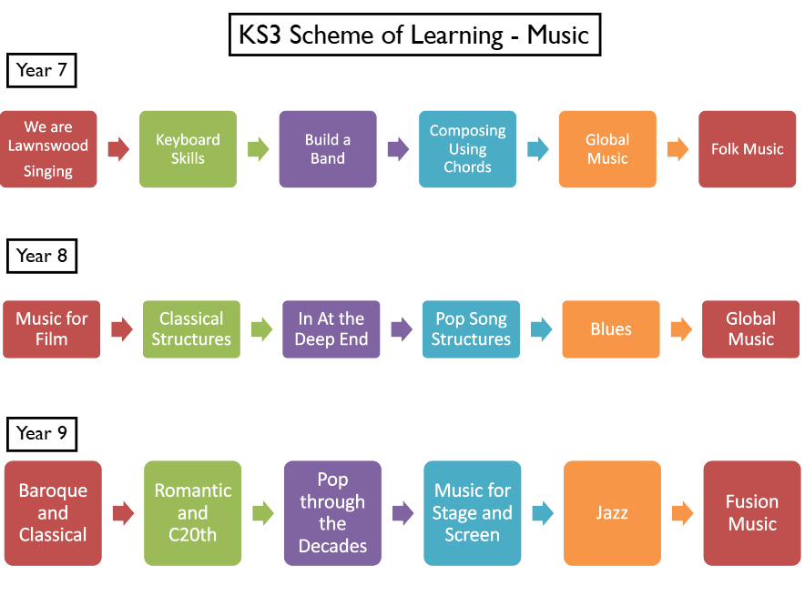  Who will teach this?  Associate Assistant Headteacher and Head of subject – Rachel Rushton  Deputy Headteacher and Teacher of Music – Martin Truscott  Teacher of Music – James Heaton  How will lessons be inclusive?  All lessons are planned with the needs of individuals considered and catered for. This will include the use of specific and targeted equipment for the learners, resources which are differentiated to support the learning of new ideas and scaffolded tasks so that individuals can reach their full potential.
4 – Implementation of key components | Evidence to support the implementation of the Music curriculum can be found on our website at the address below:  https://www.lawnswoodschool.co.uk/the-curriculum/subject-areas/music/
5 – Communication activities | During the academic year we communicate via several different methods to raise the profile of the music offering to our community. We have a half termly newsletter which is shared, a Headteachers update and a X account, in which, we share performances and updates. In addition to this we have performance evenings which highlight the excellent offer that the school delivers.
6 – Evaluation process for the success of the Music Development Plan | Subject Leaders meet with Faculty Leaders to review provision and impact, curriculum reviews take place with the support of colleagues in the Leeds Learning Partnership and success is measured through a range of qualitative and quantitative data.
7 – Transition work with local primary schools | Transition and outreach work with our primary schools is a priority and supports the objectives set out in our Artsmark journey.  We play an active role in visiting and workshopping with local primary schools, linking with primary school with support from our local Hub and through networking meetings.  Activities and events include  - Workshops  - Invitations to perform at concerts  - Collaborative concert and events such as the Leeds Arena Big Sing  - Transition day lessons  - Artsmark ambassador's sessions
8 – Budget materials and staffing | The Subject Leader of Music leads on spending within the department, resourcing effectively for the forthcoming academic year. Fundraising supports the budget by way of events and performances. Resources and equipment are often renewed and repaired to maintain. Staffing is a subject leader of music with two teachers of music. We also commit annually to a service level agreement with Artforms who provide weekly tuition for small group and 1-1 instrumental lessons.  We continue to boost the department resources with ICT availability, being creative with software and subscriptions.  As a Leeds Music Champion School we can access some funded subscriptions such as Musical Futures and Sing Up which are valuable for a range of curriculum and extracurricular activities.  Staff at Lawnswood engage regularly in CPD both inside and outside of school. Termly we meet and share resources within the Red Kite schools trust and the Leeds Learning Partnership.
9 – Pupil Premium and SEND provision | Curriculum is designed with all students in mind, musicality is the centre of our focus, aiming to bring a range of styles, live music opportunities and music from a range of cultures to the forefront. We plan for learning with no disadvantage.  Peripatetic small group and 1-1 lessons and instruments are readily available for all learners. Students are from a Pupil Premium cohort are funded, via bursaries through Artforms and from the school budget. Our provision via the West Yorkshire Hub and Artforms is crucial for this opportunity.  Enrichment opportunities are planned within the school day to support lunchtime uptake at clubs. After school clubs are all inclusive and plan for successful performances in school and externally.  Primary outreach projects are designed to reach the feeder schools with the highest uptake alongside the highest cohort of Pupil Premium.

Part B  Musical Events | Throughout the academic year, we have key performances and events which create opportunity for live music. These include;  September-December:  Open Evening  Performance days with Artforms (instrument specific)  School Musical Theatre Production  Winter Performances inside and outside of school  January – April:  Red Kite Battle of the Bands  Artforms Secondary Singing Day  GCSE NEA performance recordings  Primary to Secondary Lawnswood Singing Day with external Choir Leader  May – July:  Year 11 Leavers Assembly  Year 13 Leavers Assembly  Sports Day Disco  Headingley Youth Music Festival  Lawnfest  LMEP Gig at the Wardrobe  The Leeds Arena Big Sing (bi-annually)  Leeds Youth Celebration Concert at the First Direct Arena

Part D  In the Future | Regularly review the enrichment and extracurricular offer in line with student voice to improve our offer.  Develop wider opportunities to experience live music within the local community and further.  Embed our new Music IT provision across all KS3 and KS4 students  Develop our curriculum in line with statutory requirements and the needs of our students at Lawnswood  Align our musical priorities within our goals for Artsmark Gold and furthermore Platinum

Part D  Further Information | We work closely with the West Yorkshire Music Hub to support our planning, funding for projects, and delivery of curricular and co-curricular events. Please find below a link to the West Yorkshire Music Hub Website:  Artforms website:  Artforms Leeds – Arts and Music Education Service Leeds  At Lawnswood School we are proud to form part of the Red Kite Alliance. Red Kite Alliance is a partnership of Yorkshire schools and institutions, across all phases of education, from inner city locations and rural contexts, that have come together to share our skills, experience, talent and capacity to help improve the learning and achievement of the young people in our communities. A link to the website is below:  Red Kite Alliance - Home

